EDA using Auto Dataset

Question:1
This exercise relates to the College data set, which can be found in the file College.csv on the book website. It contains a number of variables for 777 different universities and colleges in the US.

a) Use the pd.read_csv() function to read the data into Python. Call the loaded data college. Make sure that you have the directory set to the correct location for the data.

Code:
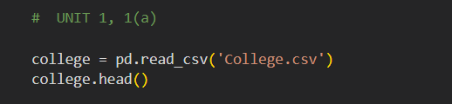

Output:
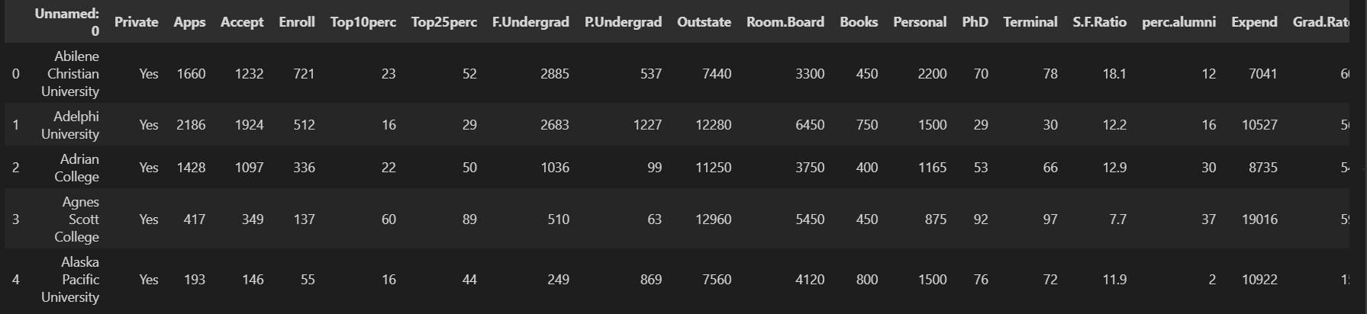

Interpretation:
The code successfully loads the College dataset into the college Data Frame and displays the first five rows.

(b) Look at the data used in the notebook by creating and running a new cell with just the code college in it. You should notice that the first column is just the name of each university in a column named something like Unnamed: 0. We don’t really want pandas to treat this as data. However, it may be handy to have these names for later. Try the following commands and similarly look at the resulting data frames:

This has used the first column in the file as an index for the data frame. This means that pandas has given each row a name corresponding to the appropriate university. Now you should see that the first data column is Private. Note that the names
college2 = pd.read_csv('College.csv', index_col=0)
college3 = college.rename({'Unnamed:0':'College'},axis=1)
college3 = college3.set_index('College')

of the colleges appear on the left of the table. We also introduced a new python object above: a dictionary, which is specified by dictionary (key, value) pairs. Keep your modified version of the data withthe following:
college = college3

Code:
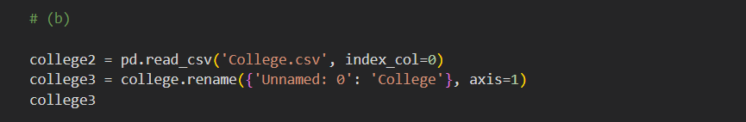
Output:
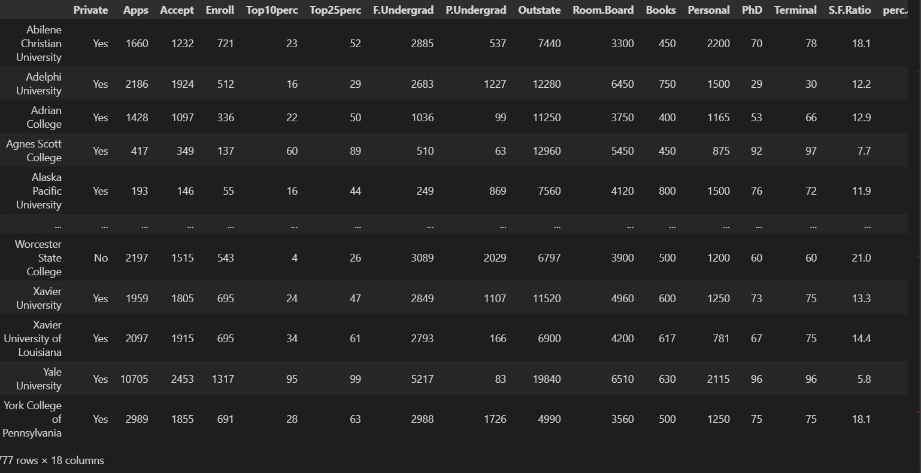
Interpretation:
The code sets college names as the DataFrame index, making each college easier to identify and analyze

(c) Use the describe() method of to produce a numerical summary of the variables in the data set.
Code:
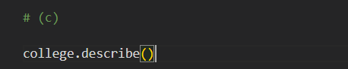
Output:
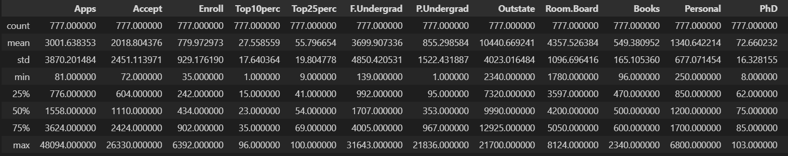
Interpretation:
The describe() method provides a numerical summary of all variables, including count, mean, standard deviation, minimum, maximum, and quartiles.

(d) Use the pd.plotting.scatter_matrix() function to produce a scatterplot matrix of the first columns [Top10perc, Apps, Enroll]. Recall that you can reference a list C of columns of a data frame A using A[C].

Code:
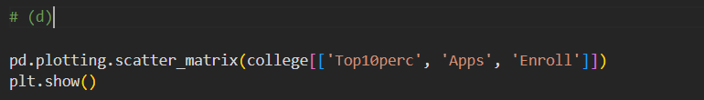
Output:
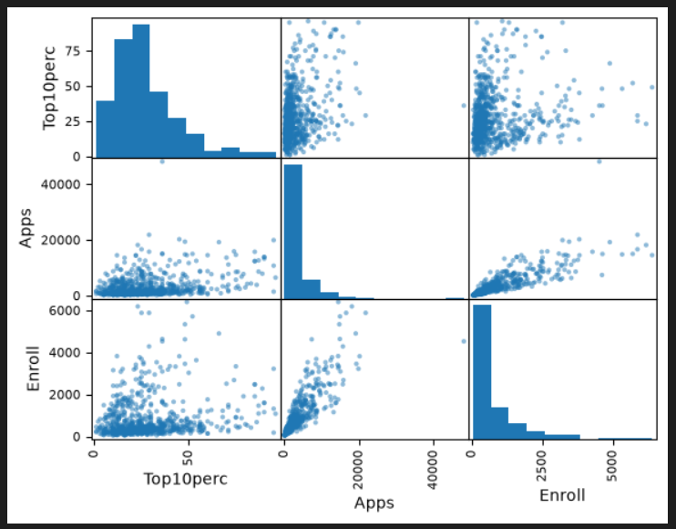
Interpretation:
The scatterplot matrix shows the relationships between Top10perc, Apps, and Enroll, indicating a positive relationship between Apps and Enroll.

(e) Use the boxplot() method of college to produce side-by-side boxplots of Outstate versus Private.

Code:
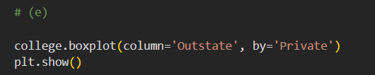
Output:
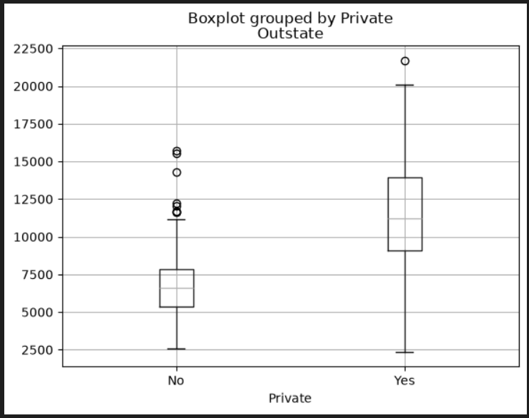
Interpretation:
The boxplot shows that private colleges generally have higher out-of-state tuition than public colleges, with some outliers in both groups.

(f) Create a new qualitative variable, called Elite, by binning the Top10perc variable into two groups based on whether or not the proportion of students coming from the top 10% of their high school classes exceeds 50%.
college['Elite'] = pd.cut(college[
'Top10perc'], [0,0.5,1],
labels=['No', 'Yes'])
Use the value_counts() method of college['Elite'] to see how many elite universities there are. Finally, use the boxplot() method again to produce side-by-side boxplots of Outstate versus Elite.

Code:
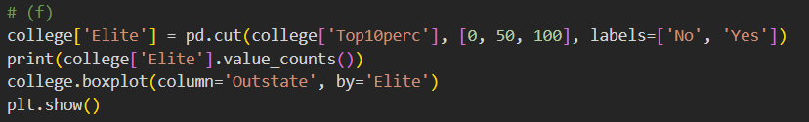

Output:
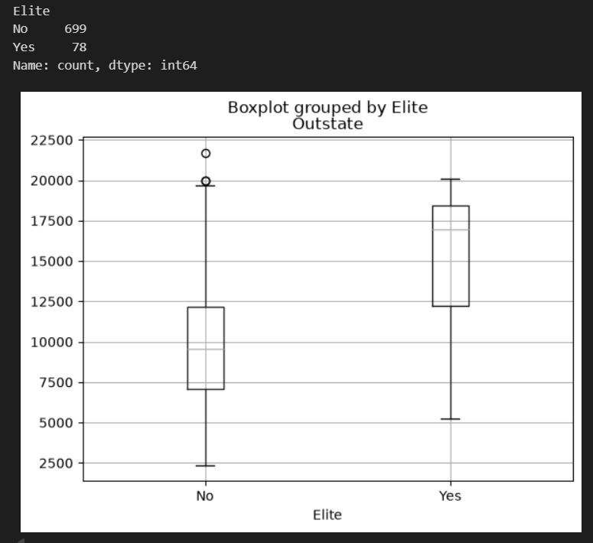
Interpretation:
The boxplot shows that elite colleges have higher out-of-state tuition than non-elite colleges.

(g) Use the plot.hist() method of college to produce some his- tograms with differing numbers of bins for a few of the quanti-tative variables. The command plt.subplots(2, 2) may be use- ful: it will divide the plot window into four regions so that four plots can be made simultaneously. By changing the arguments you can divide the screen up in other combinations.
Code:
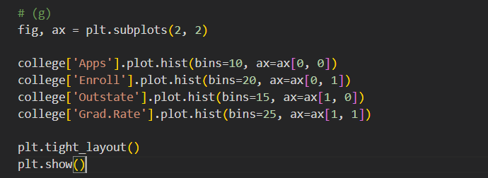
Output:
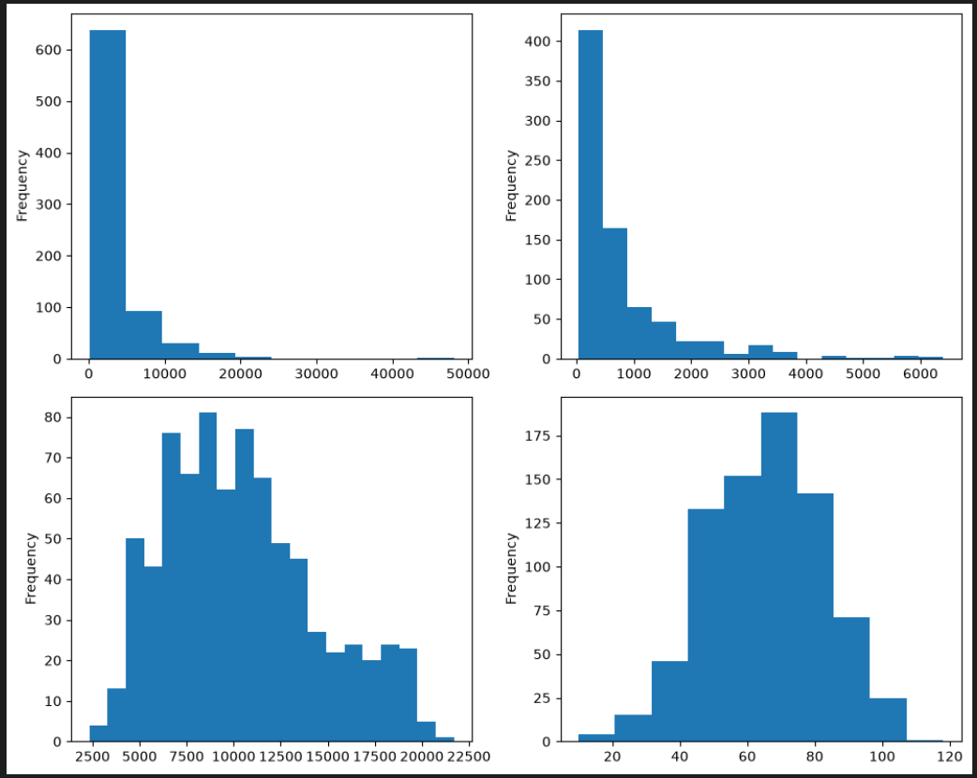
Interpretation:
The histograms show the distributions of Apps, Enroll, Outstate, and Grad.Rate, with most variables being right-skewed except Grad.Rate.

(h) Continue exploring the data, and provide a brief summary of what you discover.

Code:

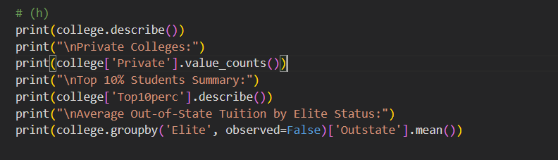

Output:

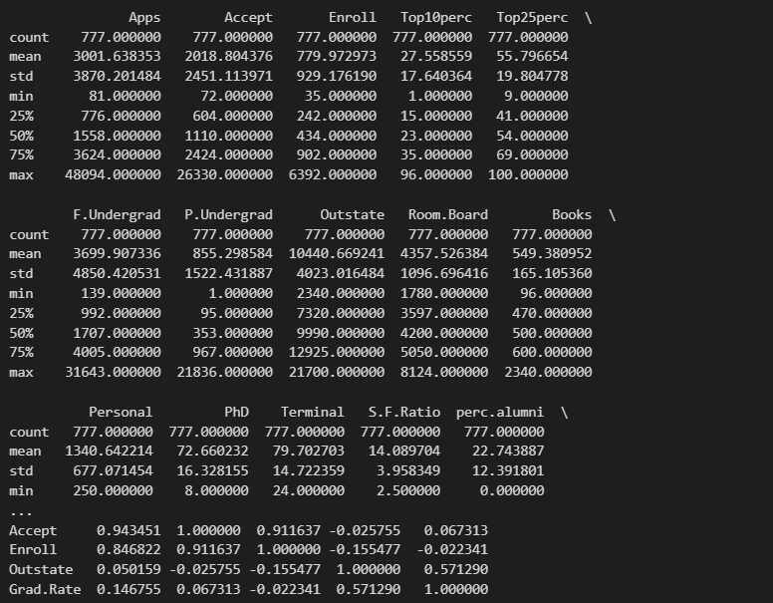

Interpretation:
The data shows that private colleges are fewer, elite colleges generally have higher out-of-state tuition, and application and enrollment numbers vary widely.

